**DAILY ONLINE ACTIVITIES SUMMARY**

|  |  |  |  |  |  |  |  |  |
| --- | --- | --- | --- | --- | --- | --- | --- | --- |
| **Date:** | **30-06-2020** | | | | | **Name:** | **Shiza Amreen.J** | |
| **Sem & Sec** | **4th Sem B Sec** | | | | | **USN:** | **4AL18CS078** | |
| **Online Test Summary** | | | | | | | | |
| **Subject** | | **C++ Programming** | | | | | | |
| **Max. Marks** | | **30** | | **Score** | | | **25** | |
| **Certification Course Summary** | | | | | | | | |
| **Course** | **Introduction to R** | | | | | | | |
| **Certificate Provider** | | | **GreatLearning** | | **Duration** | | | **3 Hours** |
| **Coding Challenges** | | | | | | | | |
| **Problem Statement:**   1. [**Write a C++ Program to Move all zeroes to end of array using Two-Pointers**](https://github.com/orgs/alvas-education-foundation/teams/2nd-year/discussions/140) 2. [**Write a C Program to check whether the number is Ugly or not.**](https://github.com/orgs/alvas-education-foundation/teams/2nd-year/discussions/141) | | | | | | | | |
| **Status: Completed** | | | | | | | | |
| **Uploaded the report in Github** | | | | | **Yes** | | | |
| **If yes Repository name** | | | | | **Lockdown_coding**  <https://github.com/ShizaAmreen/Lockdown_coding> | | | |
| **Uploaded the report in slack** | | | | | **Yes** | | | |

Online Test Details: 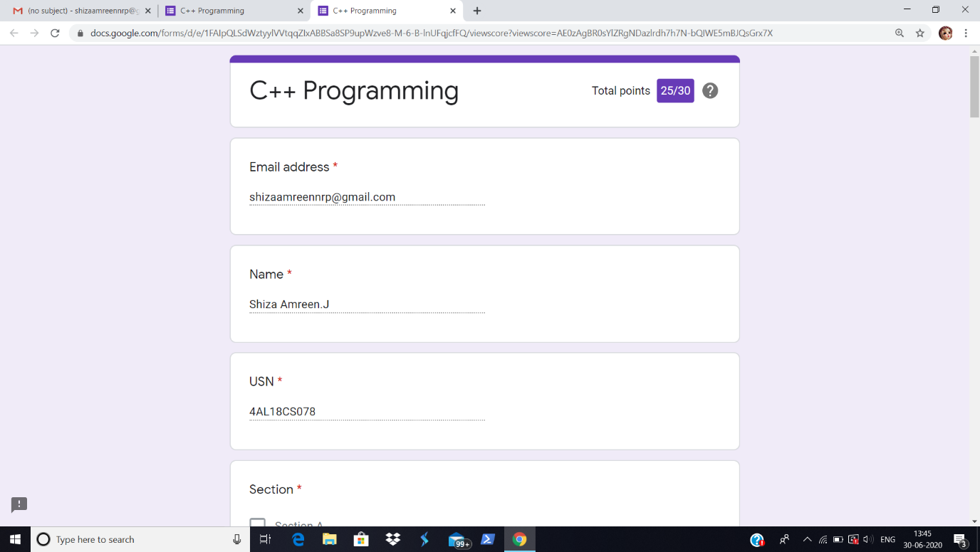

Today we had C++ Programming Webinar, I have attended it and taken the quiz, and got 25 out of 30.

Certification Course Details:

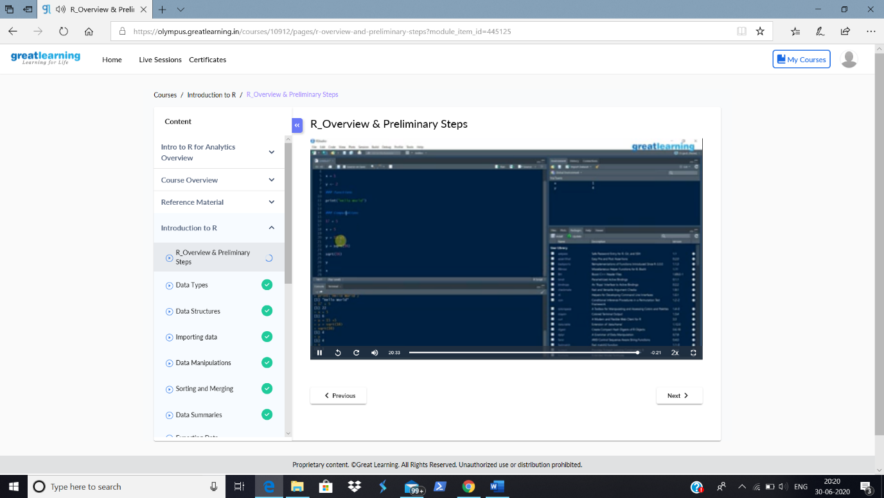

Today in the course, I have learnt about R Overviews and Preliminary Steps.

Coding Challenges Details:

|  |
| --- |
| **Problem Statement:**   1. [**Write a C++ Program to Move all zeroes to end of array using Two-Pointers**](https://github.com/orgs/alvas-education-foundation/teams/2nd-year/discussions/140) 2. [**Write a C Program to check whether the number is Ugly or not.**](https://github.com/orgs/alvas-education-foundation/teams/2nd-year/discussions/141) |

**I have written the code for given problem statement and uploaded it in my github repository, Lockdown_coding.**

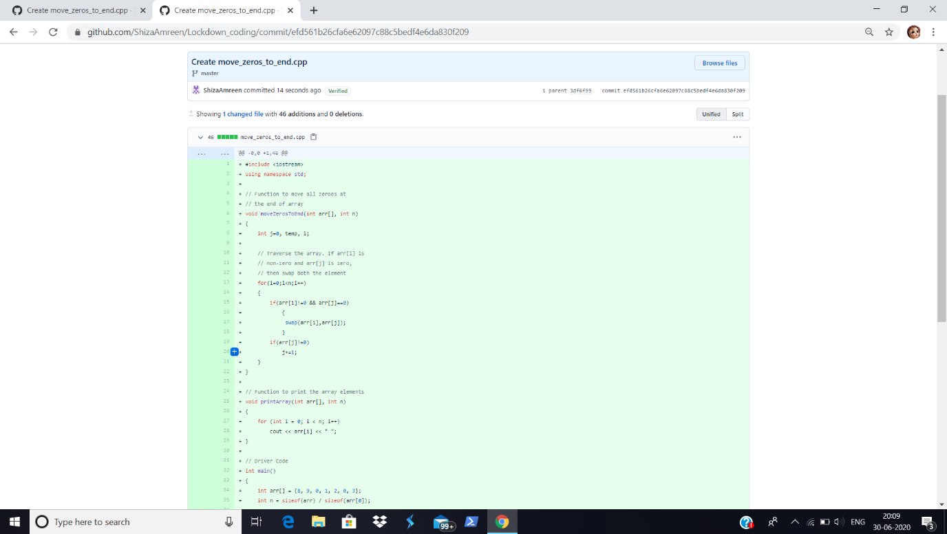

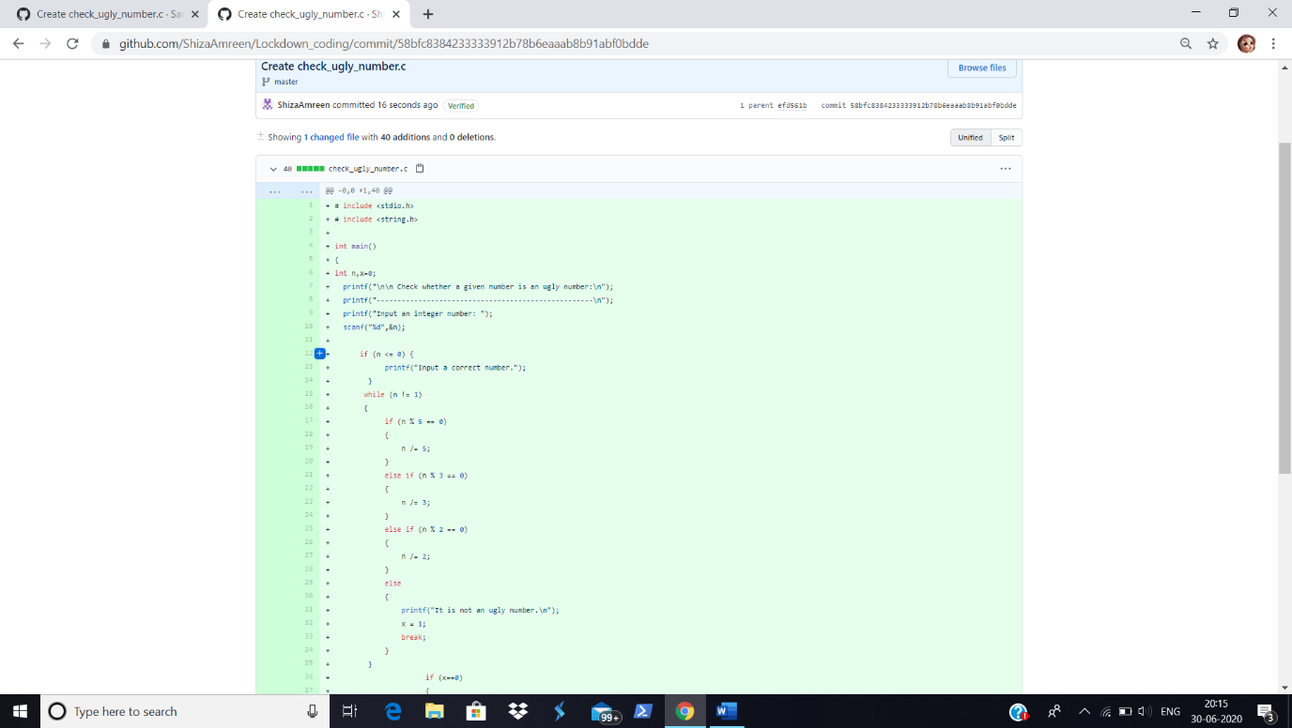

<https://github.com/ShizaAmreen/Lockdown_coding/commit/efd561b26cfa6e62097c88c5bedf4e6da830f209>

<https://github.com/ShizaAmreen/Lockdown_coding/commit/58bfc8384233333912b78b6eaaab8b91abf0bdde>